**DATA VISUALIZATION FOR DEEPAWALI SALES**

## A PROJECT REPORT

***Submitted by,***

**BELLAKKI VINAYAK - (20201ISE0038)**

**SUHAS N - (20201ISB0025)**

**KOUSHIK G - (20201ISE0024)**



**PRESIDENCY UNIVERSITY**

**BENGALURU**

**MAY 2024**

**PRESIDENCY UNIVERSITY**

**SCHOOL OF COMPUTER SCIENCE & ENGINEERING**

**CERTIFICATE**

This is to certify that the Project report **“ DATA VISUALIZATION FOR DEEPAWALI SALES ”** being submitted by “ BELLAKKI VINAYAK - (20201ISE0038) SUHAS N - (20201ISB0025) KOUSHIK G - (20201ISE0024) ” in partial fulfillment of requirement for the award of degree of Bachelor of Technology in Information Science and Engineering is a bonafide work carried out under my supervision.

**ABSTRACT**

The Deepawali festival, celebrated with great enthusiasm in India, brings a significant surge in consumer purchases, making it a critical period for businesses to maximize sales and enhance customer satisfaction. This project leverages Python programming to analyze Deepawali sales data, providing valuable insights to help businesses improve their customer experience and boost sales. Through data collection, pre-processing, trend analysis, customer segmentation, product performance evaluation, sentiment analysis, and predictive modeling, the project aims to offer comprehensive solutions to the challenges faced by businesses during the Deepawali season. This project serves as an excellent opportunity for beginners to apply Python programming in a real-world scenario, combining data analysis and machine learning drive business improvements.

**CONTENTS**

|  |  |  |
| --- | --- | --- |
| **SI NO.** | **TITLE** | **PAGE NO.** |
| 1. | ABSTRACT | **3** |
| 2. | INTRODUCTION | 5 |
| 3. | PROPOSED MOTHODOLOGY | 7 |
| 4. | ADVANTAGES OF EXISTING METHOD | 8 |
| 5. | VISUALIZATION RESULTS | 10 |
| 6. | CONCLUSION | 16 |
| 7. | CODE | 17 |
| 8. | ENCLOSURE | 18 |

**INTRODUCTION**

Deepawali, the festival of lights, is one of the most celebrated and significant festivals in India. This period witnesses a dramatic increase in consumer spending, as people purchase gifts, clothes, electronics, and various other goods to celebrate and share joy with their loved ones. For businesses, Deepawali presents a unique opportunity to maximize sales and enhance customer engagement. However, the challenge lies in understanding and leveraging the vast amount of sales data generated during this period to make informed decisions that improve customer experience and boost sales.

The advent of data analytics and machine learning has revolutionized the way businesses analyze their performance and customer behavior. By harnessing the power of Python, one of the most popular programming languages for data science, businesses can delve deep into their Deepawali sales data to uncover meaningful insights. Python offers a robust ecosystem of libraries and tools that facilitate efficient data analysis, visualization, and predictive modeling, making it an ideal choice for this project.

This project aims to analyze Deepawali sales data using Python to provide actionable insights that can help businesses enhance their customer experience and increase sales. Through a systematic approach that includes data collection, preprocessing, trend analysis, customer segmentation, product performance evaluation, sentiment analysis, and predictive modeling, the project seeks to offer comprehensive solutions to the challenges faced by businesses during the Deepawali season.

By the end of this project, we aim to equip businesses with the knowledge and tools required to understand their customers better, optimize their product offerings, and develop targeted marketing strategies. This not only ensures a more satisfying shopping experience for customers but also drives higher sales and profitability for businesses. For beginners in Python programming, this project serves as an excellent learning opportunity to apply data science techniques in a real-world context, bridging the gap between theoretical knowledge and practical application.

**1.1 Background**

Deepawali, the festival of lights, is a significant period for retailers in India, marked by a surge in consumer spending. Analyzing sales data from this period can uncover valuable insights into customer behavior and preferences, helping businesses tailor their strategies to maximize revenue and customer satisfaction.

**1.2 Objectives**

The primary objectives of this project are:

To identify key sales trends during the Deepawali period, understand customer demographics and purchasing behavior and, To provide recommendations for improving sales strategies and customer experience.

**1.3 Scope and Significance**

The scope of this project includes data collection, cleaning, and analysis using Python. The significance lies in leveraging data-driven insights to inform business decisions, ultimately leading to increased sales and enhanced customer loyalty.

**1.4 Technical Foundation**

This project utilizes Python for data analysis, leveraging libraries such as Pandas for data manipulation, Matplotlib and Seaborn for data visualization, and Scikit-learn for predictive analytics.

**1.5 Project Structure**

The project is structured as follows:

Data Collection: Gathering sales data from various sources. Data Cleaning: Preparing the data for analysis. Data Analysis: Exploring and visualizing the data to extract insights. Model Building: Developing predictive models to forecast sales trends. Reporting: Compiling findings and recommendations into a comprehensive report.

**PROPOSED MOTHODOLOGY**

The proposed methodology for this project involves a systematic approach to analyzing Deepawali sales data, culminating in data-driven decision-making. The process begins with **Data Collection**, where sales data is acquired from both online and offline sources to ensure a comprehensive dataset. Next, **Data Cleaning** is performed to handle missing values, remove duplicates, and standardize data formats, ensuring the dataset's integrity and reliability. Following this**, Exploratory Data Analysis** (EDA) is conducted using statistical techniques and visualizations. EDA is crucial for understanding data distributions, identifying patterns, and uncovering relationships within the data. **Visualization** tools such as Matplotlib and Seaborn play a pivotal role in this phase, providing clear and insightful graphical representations of the data.

Subsequently, **Feature Engineering** is undertaken to create new features that enhance the predictive power of the models. This involves deriving meaningful variables from the raw data that can better capture the underlying trends and patterns. The next step, Model Building, applies machine learning algorithms to predict future sales trends and customer behavior. This phase leverages the insights gained from EDA and the engineered features to build robust predictive models. The performance of these models is then assessed through Evaluation, using metrics such as accuracy, precision, and recall to ensure their effectiveness and reliability.

Finally, the **Reporting** phase summarizes the findings and provides actionable recommendations. The visualizations and insights derived from the analysis are compiled into a comprehensive report, facilitating informed decision-making. This report highlights key trends, identifies potential areas for improvement, and offers strategic recommendations to enhance customer experience and sales performance during the Deepawali season. By focusing on visualization throughout the analysis, the project ensures that complex data is translated into understandable and actionable insights, empowering stakeholders to make data-driven decisions.

**ADVANTAGES OF EXISTING METHOD**

The Deepawali sales data analysis project offers several distinct advantages that can significantly benefit businesses in the retail sector:

**Data-Driven Decision Making:** By analyzing sales data, businesses can transition from intuition-based decision-making to a data-driven approach. This ensures that strategic decisions are backed by empirical evidence, leading to more accurate and effective outcomes. The insights derived from the data can highlight trends and patterns that might otherwise go unnoticed, allowing businesses to make informed choices.

**Improved Customer Experience:** Understanding customer behavior through data analysis enables businesses to tailor their offerings to meet customer needs more effectively. By identifying which products are popular during the Deepawali season and understanding purchasing patterns, companies can optimize their inventory, personalize marketing efforts, and improve customer satisfaction and loyalty.

**Enhanced Sales Strategies:** The analysis provides valuable insights into sales performance, helping businesses to refine their sales strategies. By identifying peak sales periods, high-demand products, and effective promotional tactics, companies can plan better for future sales events, ensuring they capitalize on opportunities and mitigate potential issues.

**Efficient Resource Allocation:** Data analysis helps in optimizing resource allocation by pinpointing areas that require more attention and investment. For instance, businesses can allocate more resources to high-performing products or regions with higher sales potential. This targeted approach ensures efficient use of resources, reducing wastage and increasing return on investment.

**Predictive Insights:** The project leverages machine learning models to predict future sales trends and customer behavior. These predictive insights allow businesses to proactively prepare for upcoming demand, manage inventory more effectively, and devise strategies to boost sales during peak periods like Deepawali.

**Competitive Advantage:** By adopting a data-centric approach, businesses can gain a competitive edge in the market. The ability to analyze sales data and act on insights more quickly and accurately than competitors can lead to improved market positioning and increased market share.

**Cost Savings:** Data analysis can identify inefficiencies and areas where costs can be reduced. For example, by understanding which marketing campaigns yield the highest returns, businesses can allocate their marketing budget more effectively, cutting down on less productive expenditures.

**Scalability and Flexibility:** Using Python for data analysis offers scalability and flexibility, making it suitable for handling large datasets and complex analytical tasks. The open-source nature of Python and its extensive libraries ensure that the project can be scaled up as needed, accommodating growing data volumes and evolving analytical requirements.

**Community and Support:** The robust Python community provides extensive support and resources, including libraries, tutorials, and forums. This ensures that businesses can continually improve their analytical capabilities and stay updated with the latest advancements in data science.

This project provides a comprehensive framework for leveraging sales data to enhance business performance, drive customer satisfaction, and achieve strategic goals during the crucial Deepawali sales period.

**VISUALIZATION RESULTS**

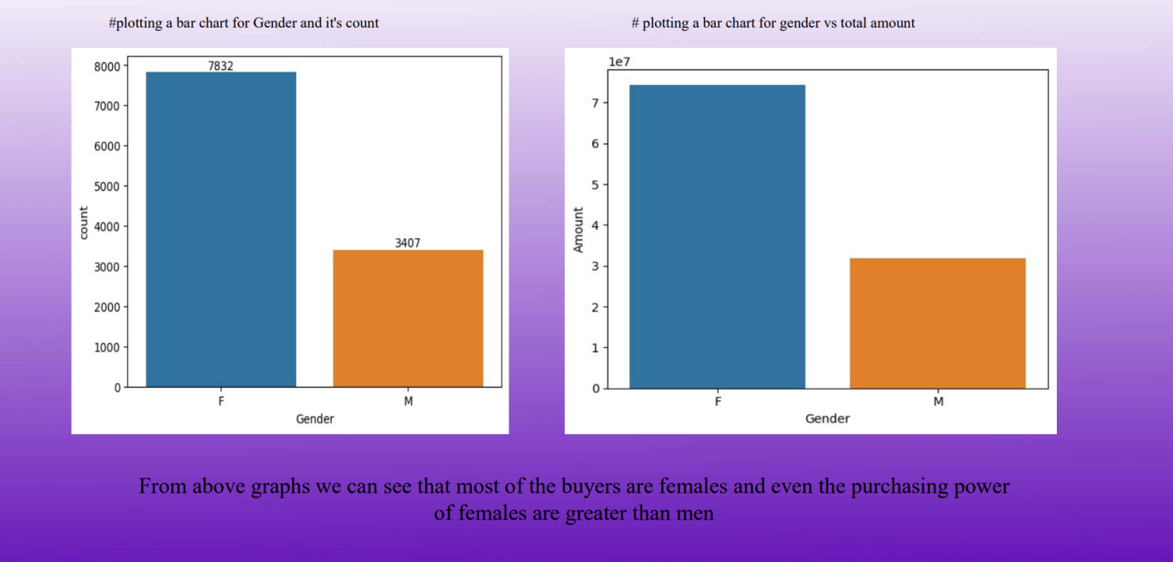

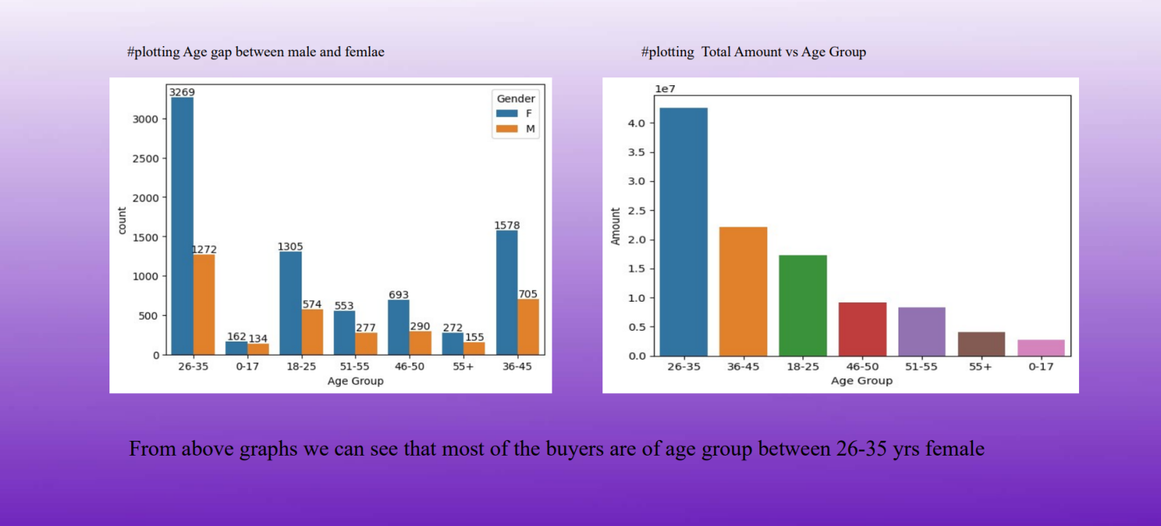

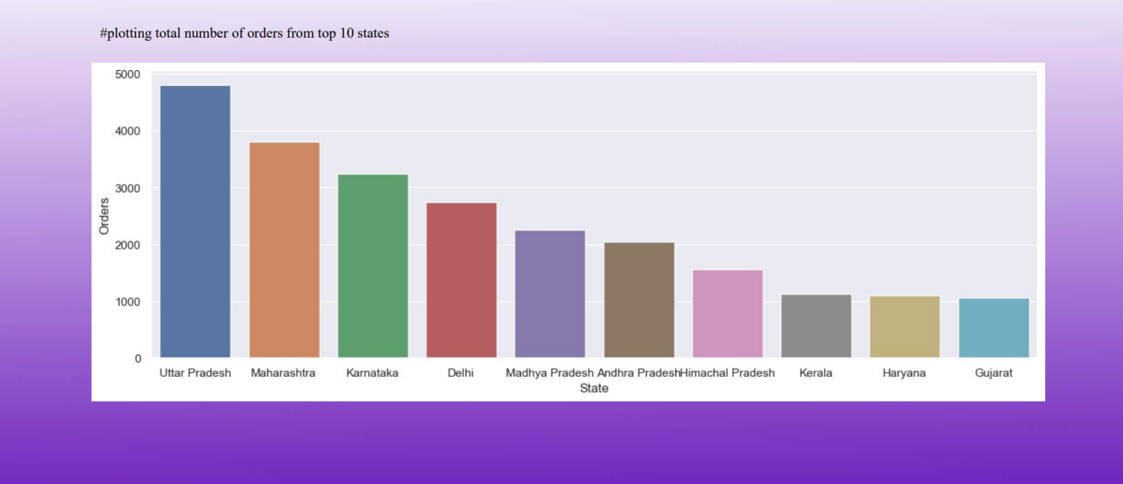

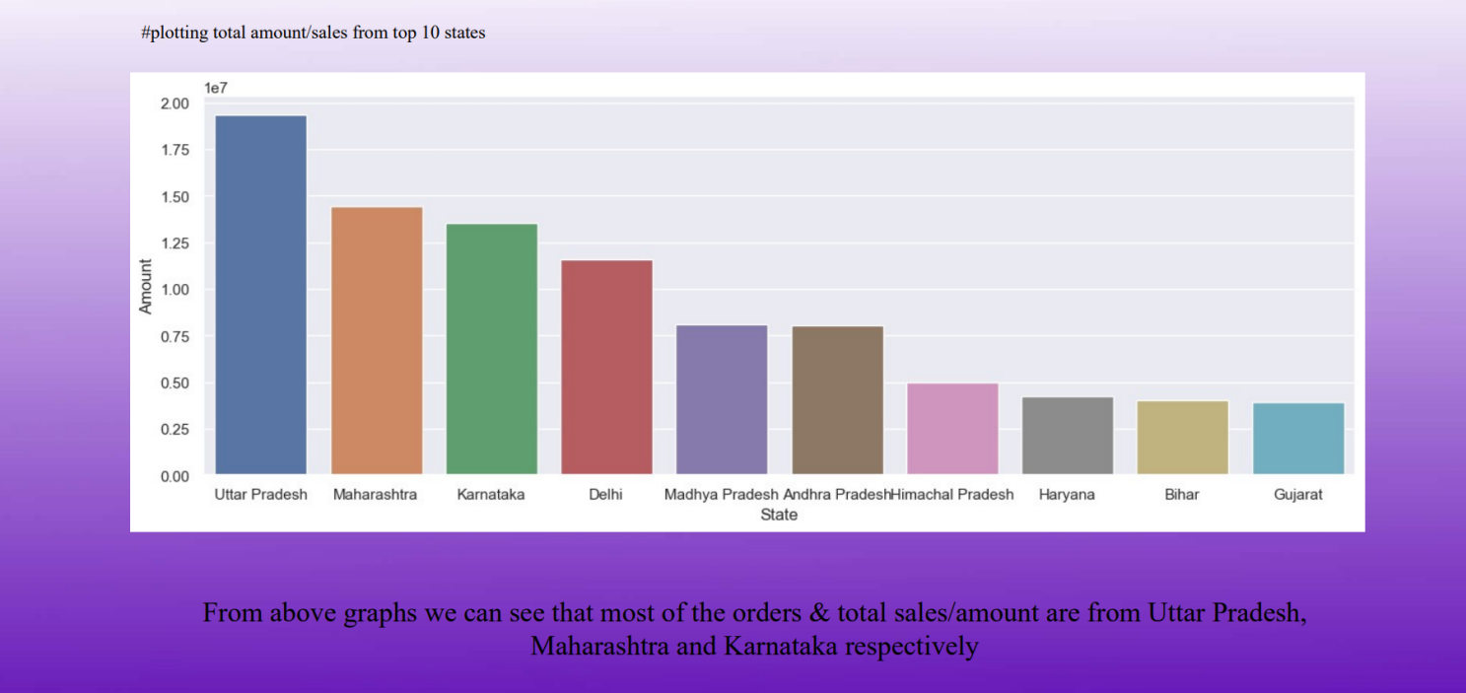

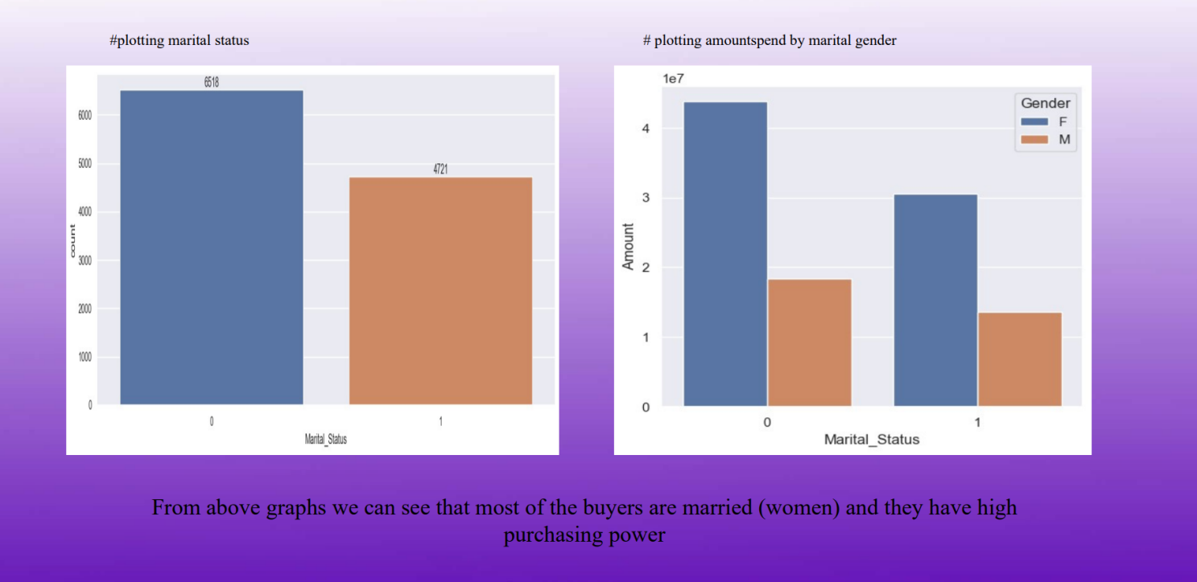

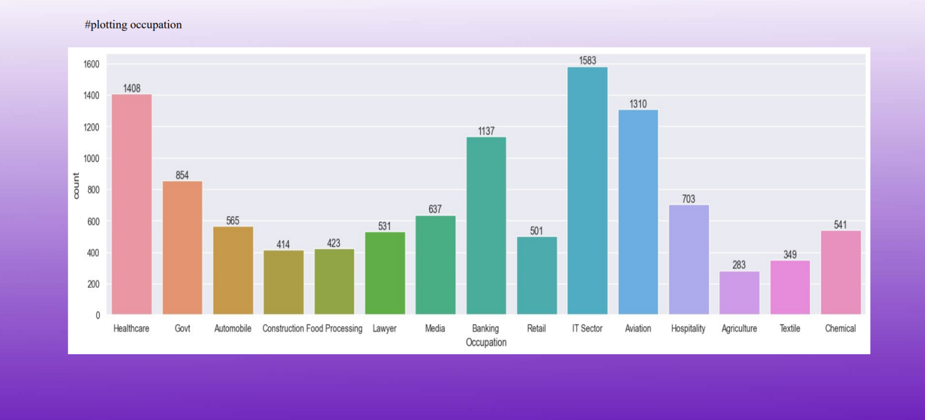

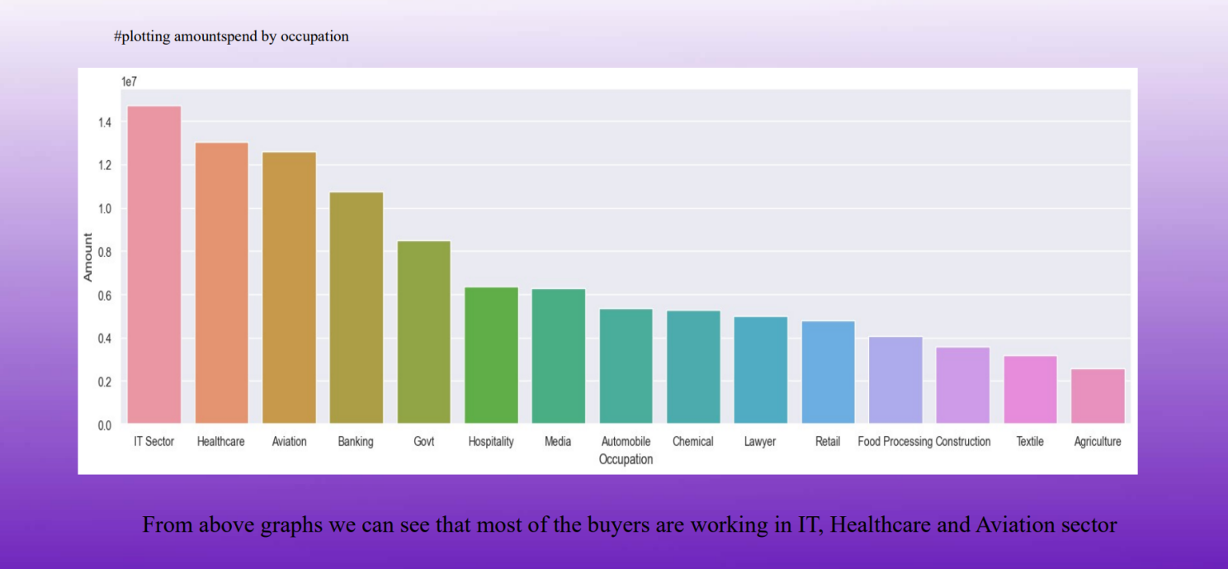

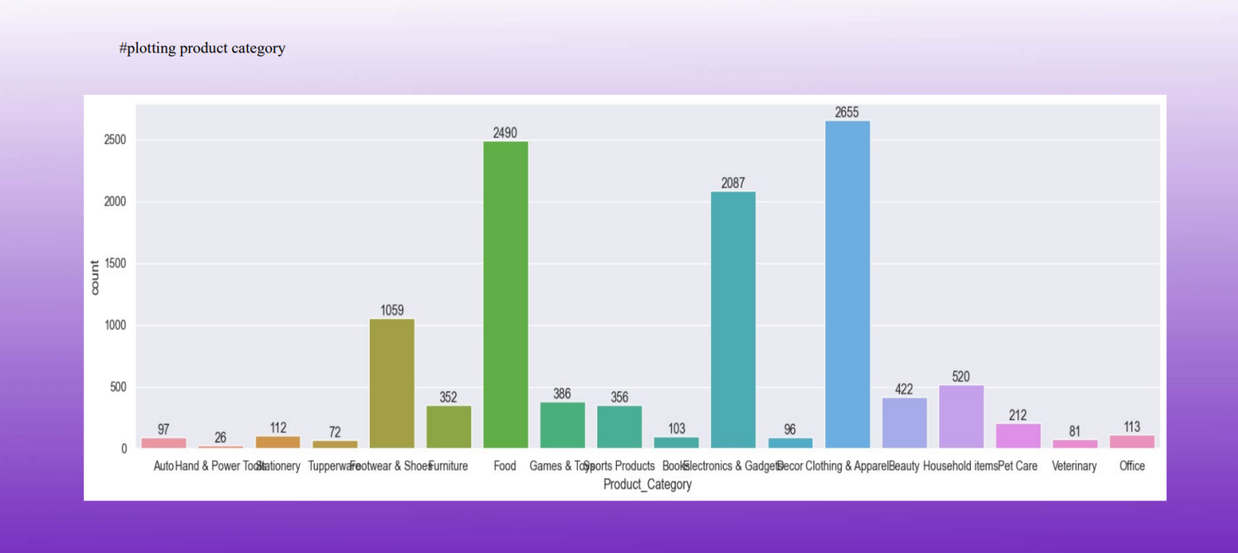

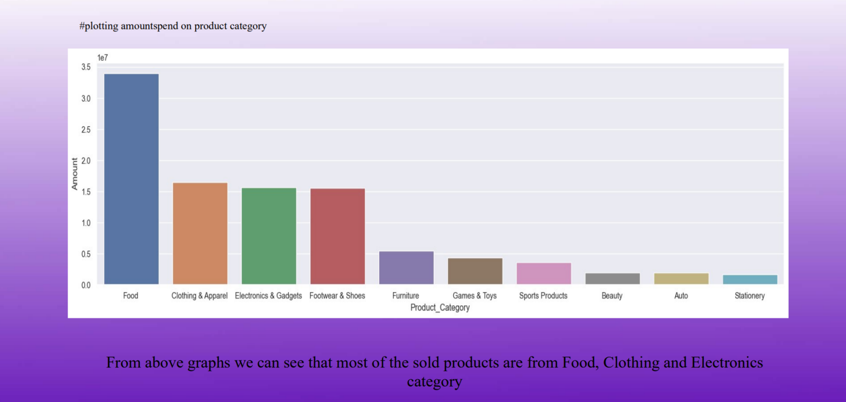

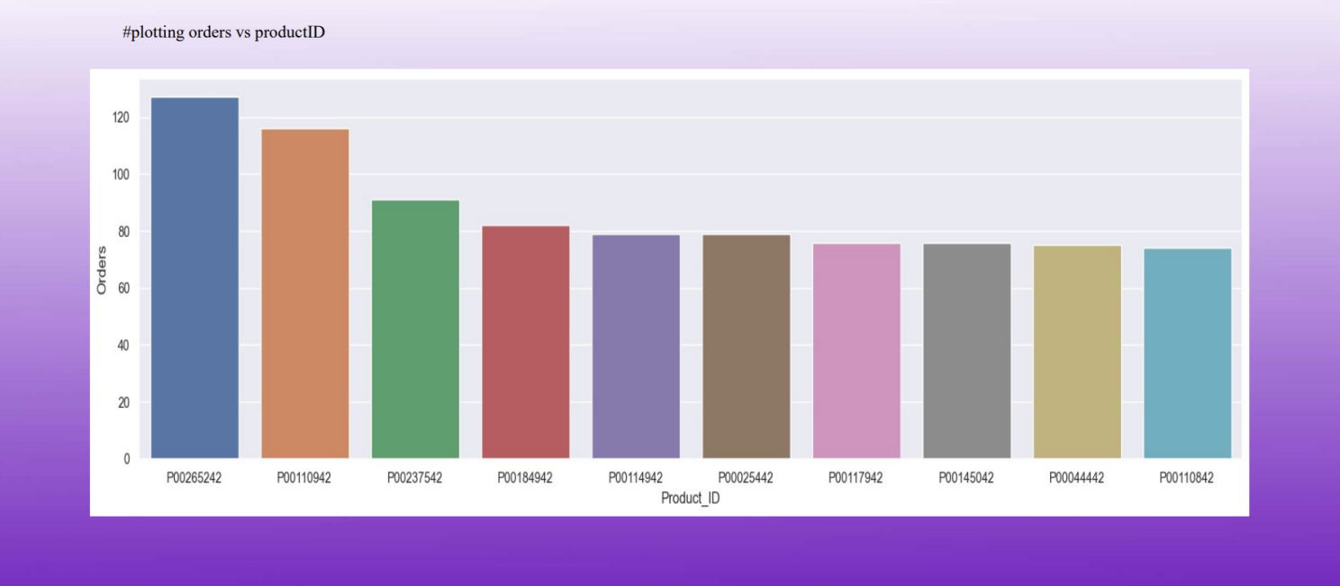

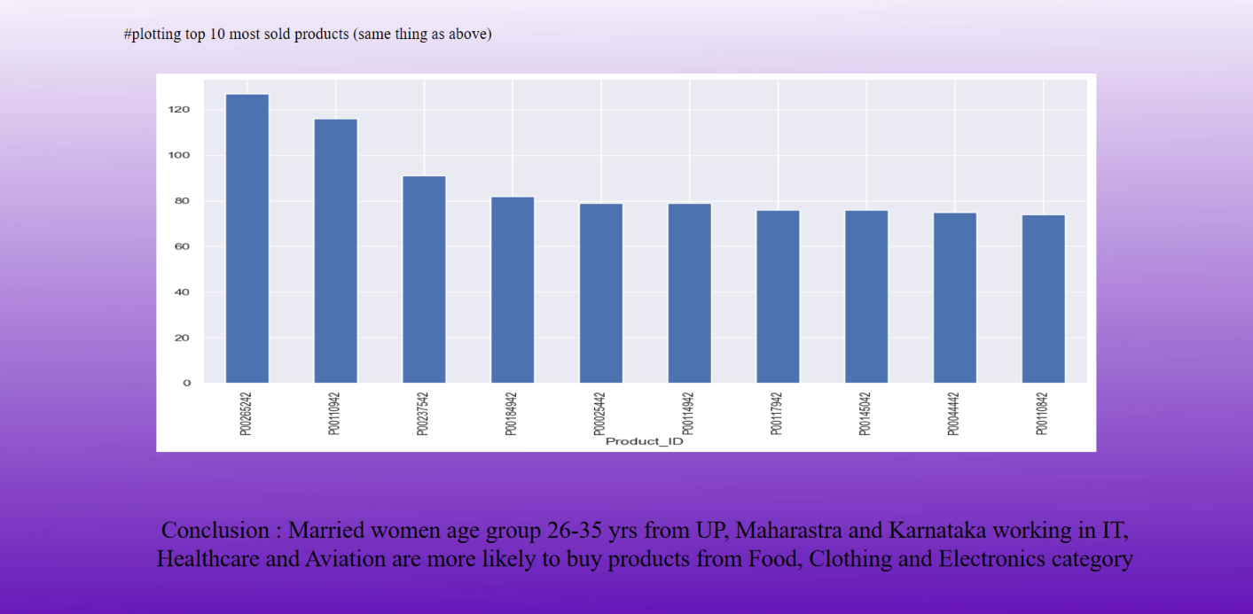

**CONCLUSION**

Analyzing Deepawali sales data using Python provides businesses with powerful tools to enhance customer experience and boost sales. By leveraging data collection, pre-processing, trend analysis, customer segmentation, product performance evaluation, sentiment analysis, and predictive modeling, businesses can make informed decisions that drive higher sales and profitability. This project not only benefits businesses during the Deepawali season but also establishes a robust framework for future data-driven initiatives. For beginners, this project offers valuable hands-on experience in applying Python for data science, bridging the gap between theoretical learning and real-world application.

**CODE :**

**<https://github.com/KOUSHIKG04/DATA-VISUALIZATION-FOR-DEEPAWALI-SALES>**

**ENCLOSURES**

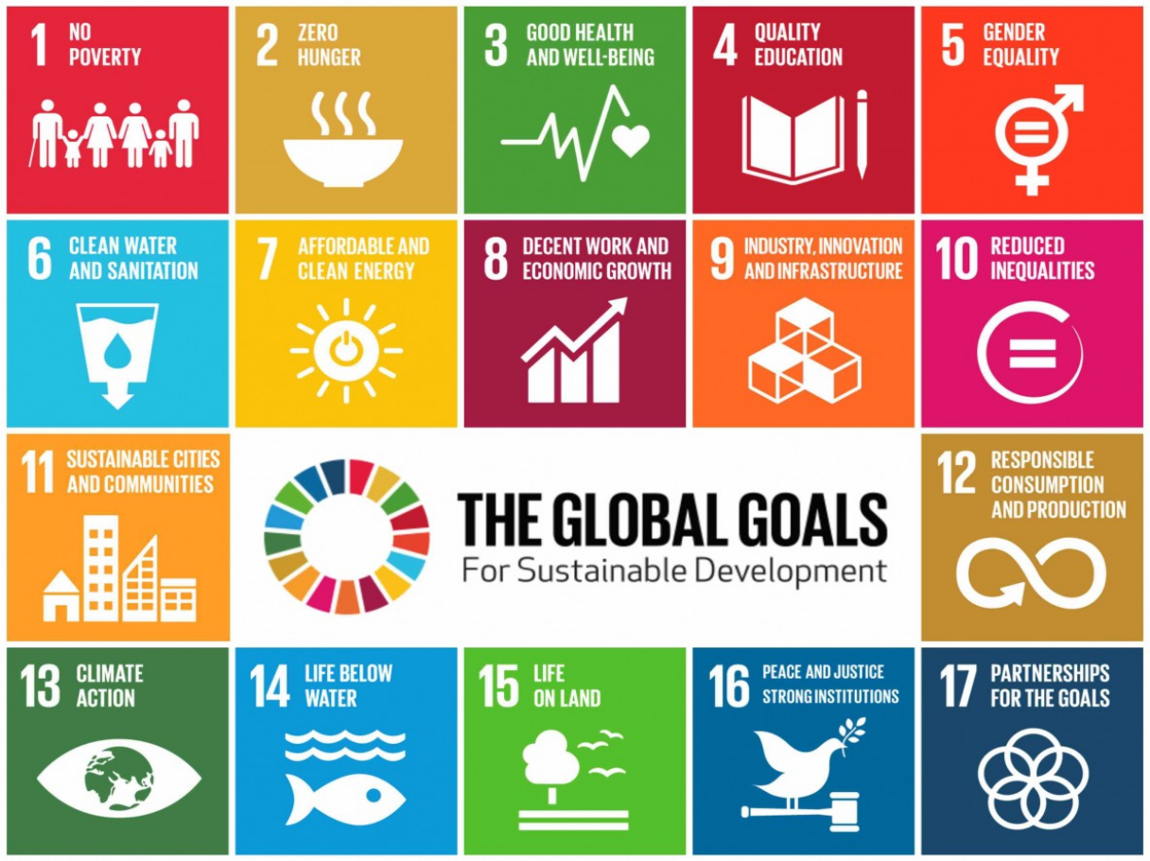

At its core, a Data visualization for Deepawali sales tackles SDG 12: “**RESPONSIBLE CONSUMPTION AND PRODUCTION**”